**Exercise Adventure Works quarterly report**

**Introduction**

In this module, you have learned about the creative processes involved in creating engaging dashboards and reports using Microsoft Power BI.

Throughout these weeks, you learned about visualization and design best practices, designing powerful report pages, and the process of data storytelling.

To create effective and engaging visualizations in Power BI desktop and service, you learned about the criteria of chart selection. This helped build towards creating and effective data story.

In a data story, the narrative created, the data selected to present this story, and the visualizations used are the key components of an effective data story.

In this exercise, you will create a story about the quarterly sales of Adventure Works in the form of a dashboard and report. This exercise will test your data visualization and storytelling skills, which are essential to convey insights effectively.

**Scenario**

Adventure Works, a multinational bicycle manufacturer, has multiple sales operations across the globe. The company’s executive board and sales management team require quarterly sales information to assess their performance for the previous quarter. This analysis should provide them with the insights they need to make strategic decisions for their upcoming quarter.

As a data storyteller, the specific tasks you should perform in this exercise are:

1. Create a data story through a dashboard, providing an overview of quarterly sales performance for the executive board of Adventure Works.
2. Create a granular report with interactivity about the same sales period for the sales management team.
3. Highlight any trends identified, such as higher/lower sales by region, category, and salespersons.
4. Provide a conclusion summarizing the key takeaways for both the board of directors and sales management team.

**By completing this exercise, you will demonstrate your ability to:**

* Review the dataset and identify the measures and fields needed to support your story.
* Create a report in Power BI desktop by appropriate selection of chart which shows clarity to present your story.
* Publish your report on the Power BI service and create a dashboard for the executive board.
* Drive a few insights from your story that you can convey to stakeholders.

**Step 1: Download the Power BI project file**

1. Download the Power BI project file *Adventure Works Quarterly Report.pbix* by selecting the file below, and inspect the data tables and fields.
2. Download the Adventure Works logo file. You can do so by selecting the logo below and downloading it.

[Adventure Works Quarterly Report](https://d3c33hcgiwev3.cloudfront.net/4zEVcqsiRiOUhKMD4Tk2zA_8559ca82f9954dfa984a2d2b9f7c7ee1_Adventure-Works-Quarterly-Report.pbix?Expires=1712361600&Signature=FxQ43cWvKBAzOSyM9Fj5d1no5ZPZhLMT~yBl35HI0Nmw51imH8InXuZ5m-J-HbV8xH3mT6ew~Da9i5YcF4VbKV-X0xE7sDt~X87GZEUGPqpCPcBIpWImakY3PJH~pplqSMV5DhBtqZNhK2aJ6Gg94xBLf96Nz~yts3ws94AJpJI_&Key-Pair-Id=APKAJLTNE6QMUY6HBC5A" \t "_blank)

[PBIX File](https://d3c33hcgiwev3.cloudfront.net/4zEVcqsiRiOUhKMD4Tk2zA_8559ca82f9954dfa984a2d2b9f7c7ee1_Adventure-Works-Quarterly-Report.pbix?Expires=1712361600&Signature=FxQ43cWvKBAzOSyM9Fj5d1no5ZPZhLMT~yBl35HI0Nmw51imH8InXuZ5m-J-HbV8xH3mT6ew~Da9i5YcF4VbKV-X0xE7sDt~X87GZEUGPqpCPcBIpWImakY3PJH~pplqSMV5DhBtqZNhK2aJ6Gg94xBLf96Nz~yts3ws94AJpJI_&Key-Pair-Id=APKAJLTNE6QMUY6HBC5A" \t "_blank)



**Step 2: Identify the relevant data fields and create visualizations**

1. Identify the relevant data fields and measures that support the data story you are going to present to the sales team as well as the executive board.
2. Create visualizations by appropriate selection of charts for each data type you are presenting. For example, here is a list of chart types that you could use for different types of data:
   1. A column/bar chart to display sales on a time scale.
   2. A donut chart or funnel chart can show sales by category.
   3. A map visual, a pie chart, or bar chart can be used to display sales by country.
   4. A bar chart can be used to show the sales performance of salespeople.
   5. A treemap can be used to visualize units sold for each category.
   6. As the objective of the story is to show the quarterly sales performance you can add slicers for the year and quarters to interactively explore the data.
   7. You can also add top selling products, top performing regions, and salesperson to your report to support your story.Card visuals highlight key metrics for the executive board such as profit, revenue, profit margin and so on.
3. Format your visualizations to create a consistent look in terms of font size, style, and color. You need to use and customize the **Accessible City Park** theme to create a consistent look for the reports.

**Step 3: Craft a data story for the sales team.**

1. Add a descriptive title to your story and mention the timescale that your visualization covers. For example, what are you showing the sales team?
2. Arrange the visual elements you created in step 2 that are relevant to your story presenting to the sales management team in a logical sequence. Make sure to include the most valuable information at the top of the canvas and follow along accordingly.
3. Add an Adventure Works logo to your report.

**Step 4: Craft a data story for the executive board.**

1. Publish your report to **My workspace** in Power BI service. You need to make sure you apply all changes made and your report is saved to your local computer before publishing.
2. Log in to your Power BI service account and create a dashboard to tell a story about the quarterly sales performance to the executive board. Remember, you only need to pin the visuals from your report that are relevant to the executive board and support your story.
3. Add the Adventure Works logo to the dashboard.
4. Provide key takeaways from the story. You can add a text box to describe the key insights.
5. Optimize the dashboard for mobile devices.

**Conclusion**

With these steps, you have created a data story for the sales team and the executive board. You identified the data fields and measures relevant to each story and created visuals in Microsoft Power BI desktop. You then presented the visuals in the form of a Microsoft Power BI report and a dashboard in Power BI service to communicate valuable metrics of the business.

**Exemplar: Adventure Works Quarterly Report**

**Overview**

In the exercise *Adventure Works quarterly report*, you put into practice your understanding of how to craft a data story and create and optimize a dashboard for it.

Your objective for this exercise was to complete the following tasks:

* Review the dataset and identify the measures and fields needed to support your story.
* Create a report in Power BI desktop by appropriate selection of chart which shows clarity to present your story.
* Publish your report on the Power BI service and create a dashboard for the executive board.
* Drive insights from your story that you can convey to stakeholders.

This reading provides a step-by-step guide for completing these tasks, accompanied by screenshots for easy comparison with your own copy.

**Step 1: Download the Power BI project file**

1. Download the Power BI project file *Adventure Works Quarterly Report.pbix* and inspect the data tables and fields. The Power BI data model contains a **Sales** fact table and three dimension tables; **Region**, **Products**, and **Salesperson**. A **Key Measures** table is also present, unrelated to the model and only contains some key measures.

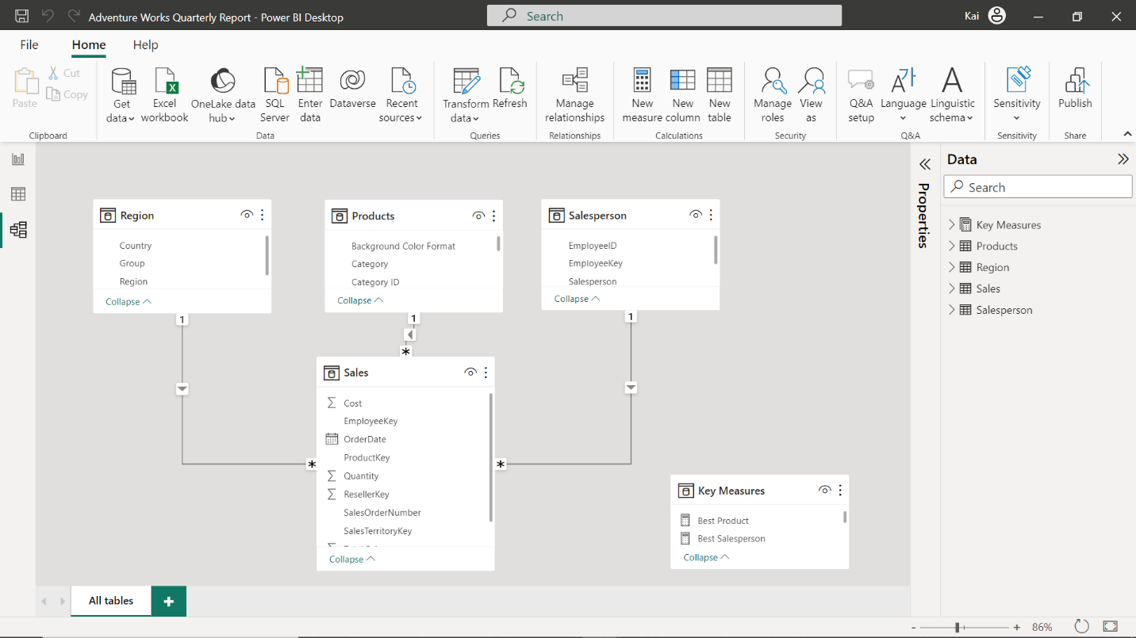

**Step 2: Identify the relevant data fields and create visualizations**

1. Identify the relevant data fields and measures that support the data story you are going to present to the sales team as well as the executive board.  The sales team might require more granular data with interactivity to drill down to a detailed level of analysis, but the Executive board only needs an overview of the sales information. Therefore, you can create a Power BI report for the sales team and a dashboard in Power BI service for the executive board. You can visualize the sales by category, country, and salesperson and introduce year and quarter slicer for interactive visualization of quarterly or yearly sales values. On the other hand, you need to consider adding snapshots of valuable information in the form of card visuals for the executive board.
2. Create visualizations by appropriate selection of chart for each data type you are presenting.

* A column or bar chart is the best option to visualize time related data. You can create a date hierarchy based on your analytical needs. In this case, you need to bring **year** and **quarter** fields from the **sales** table **date** field to the column chart **x-axis** and total sales measure on **y-axis**.

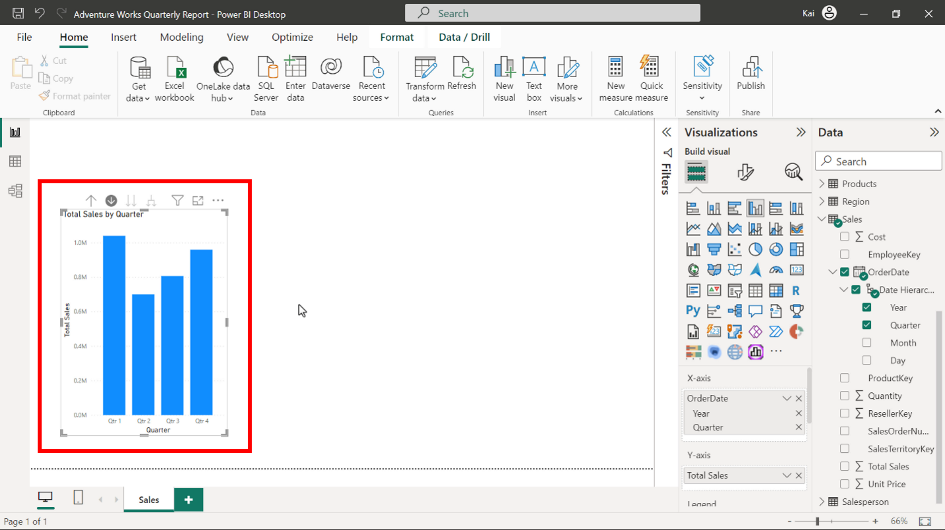

* As Adventure Works has only four product categories, you can use a donut chart to display the sales by category.

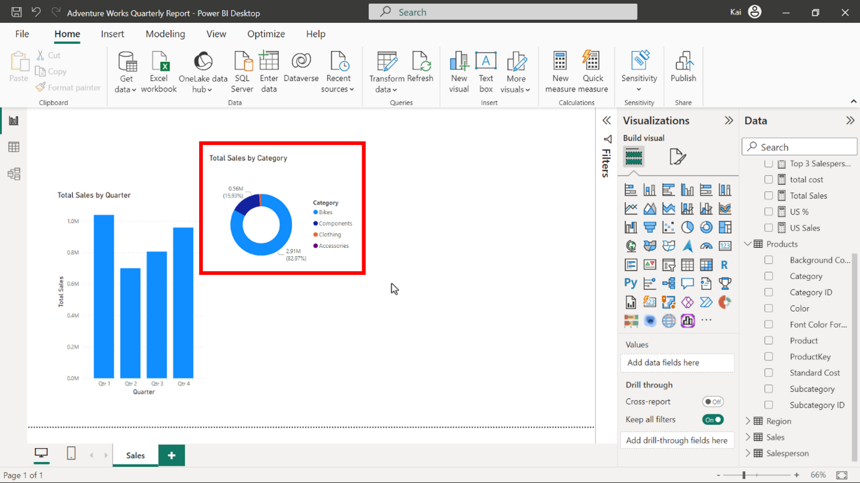

* Although you can use any map visual to display sales values by each country, to create a consistent design look, it is good to use the donut chart as there are only 6 countries worth of data available.

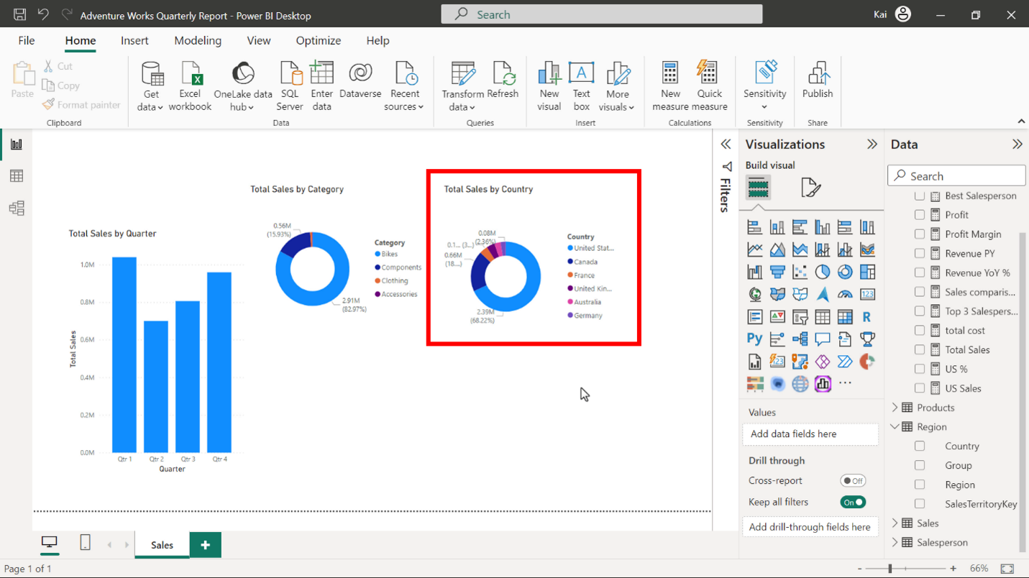

* You can use a bar chart to show the sales performance by salespersons.

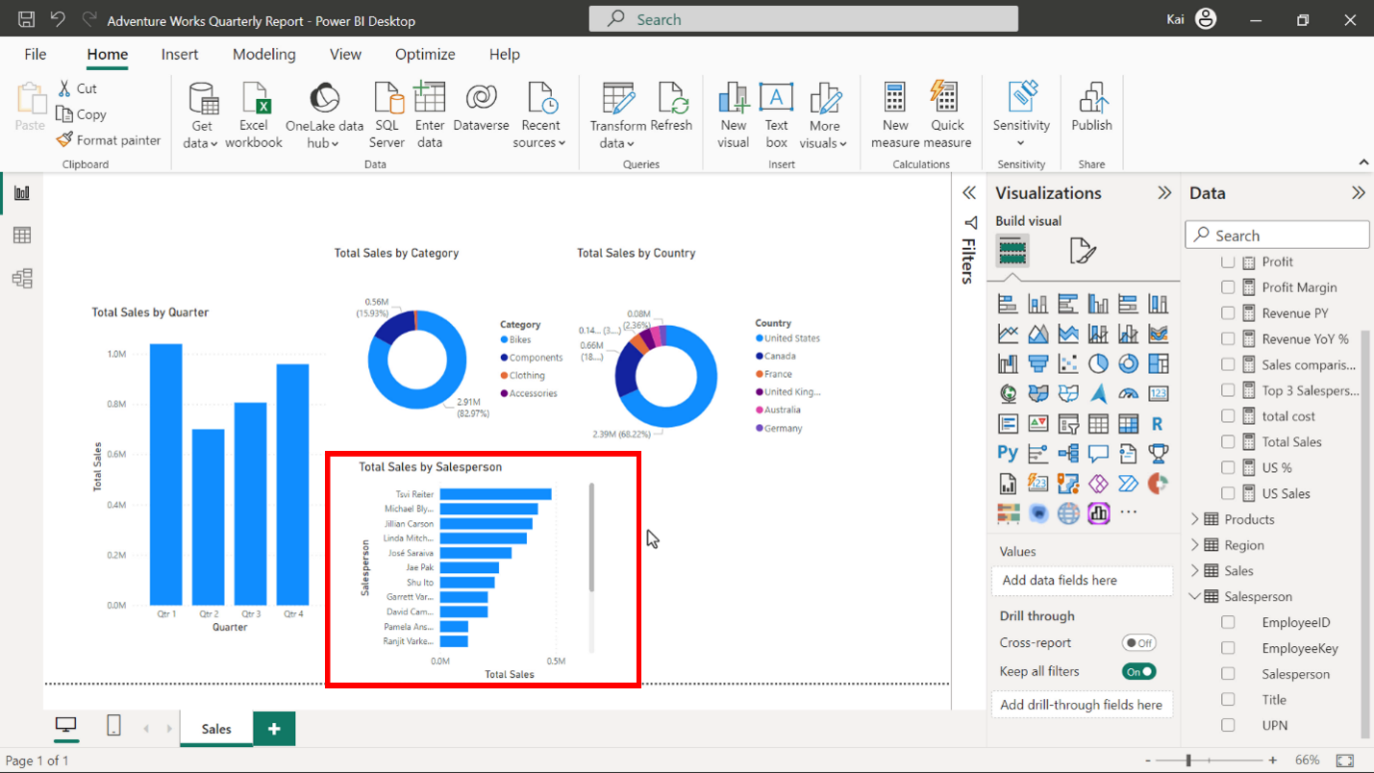

* You can use a treemap to visualize units sold for each category. The size of each rectangle proportionally represents the number of units sold per category.

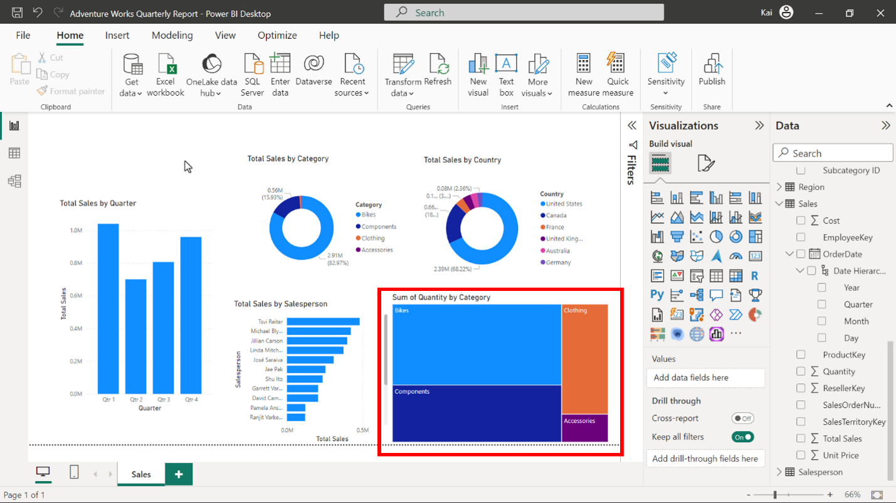

* As the objective of your data story is to show quarterly sales performance, you can add slicers for the years and yearly quarters so users can interactively explore the data. You need to create a slicer for each year and quarter respectively. You can use the tile style of slicer because there are only 4 years of data available in the report.

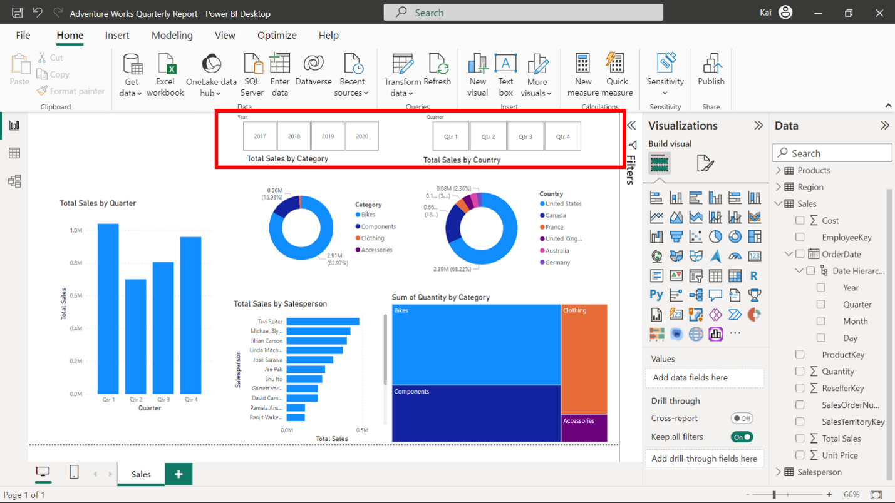

* You need to create card visuals to highlight key metrics for the executive board such as profit, revenue, profit margin and so on. Typically, the executive board needs to look at the key metrics available, therefore adding card visuals or KPIs (Key Performance Indicators) is recommended.

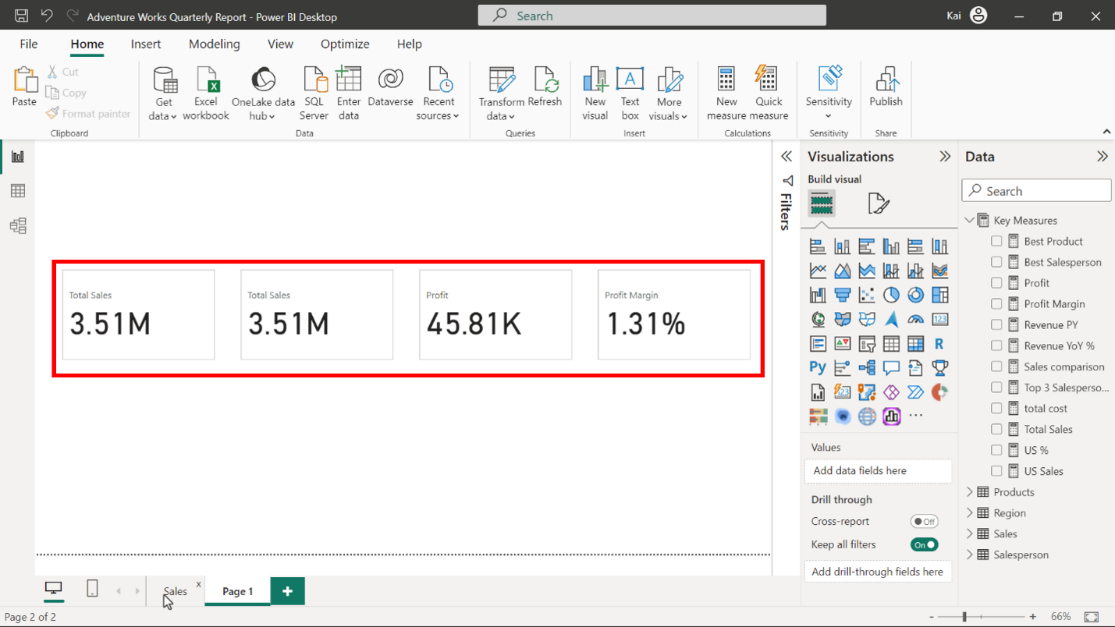

* You can add a new page to your report to create card visuals. You need to copy and paste the slicers to the new page to apply the filters to the card visuals which only displays the relevant data.

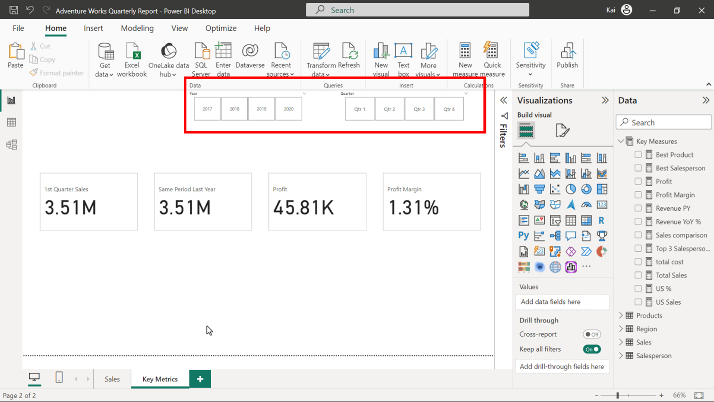

1. You first need to activate and customize the **Accessible City Park theme** from the **View** tab of Power BI desktop. You need to adjust the color to black in the second and fourth level elements. This will automatically convert all axis and legend text to black color, so you do not have to change each chart individually.

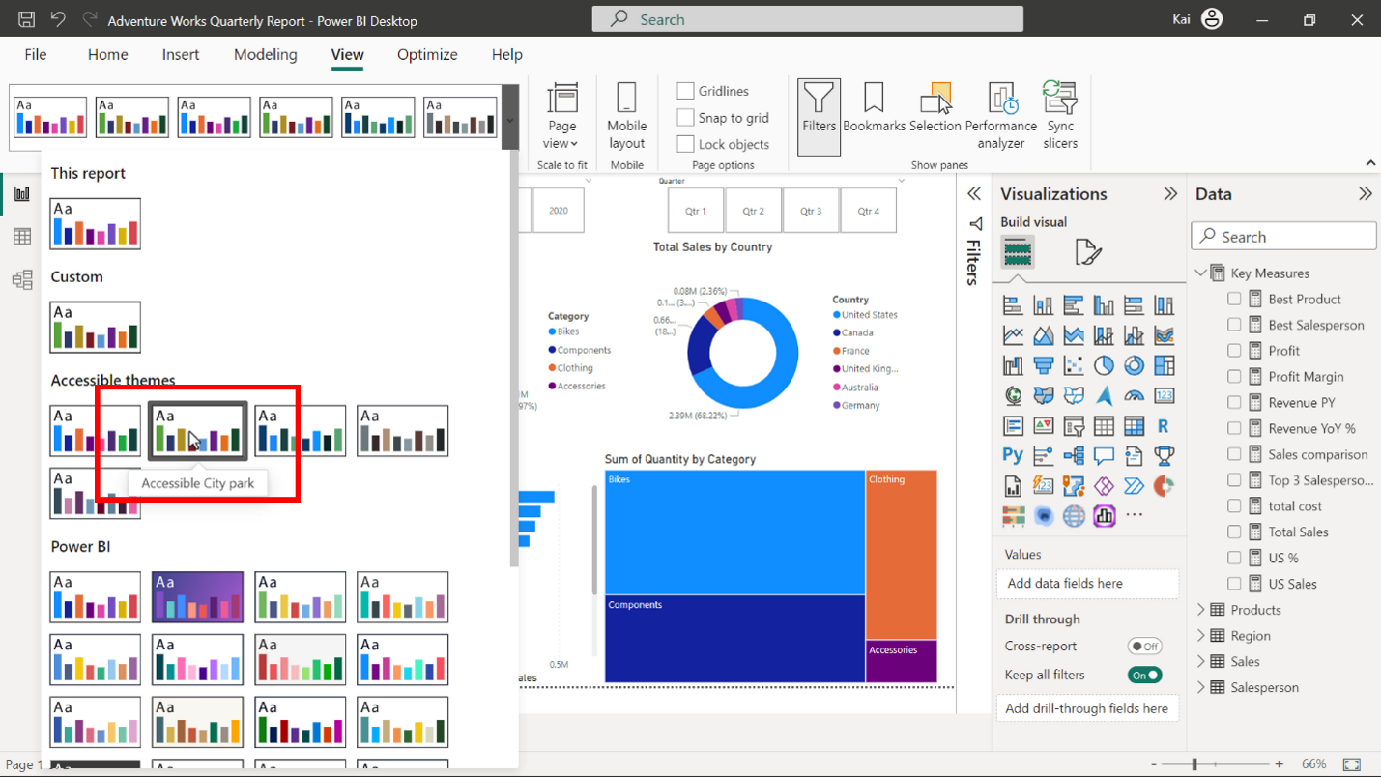

After you have activated the theme, the colors of the charts change according to the theme color palette. You need to adjust the color of individual charts if needed. For example, in the **Total Sales by Quarter** column chart all columns are blue, so you can change them to distinct colors. You can also apply conditional formatting to the bars if needed.

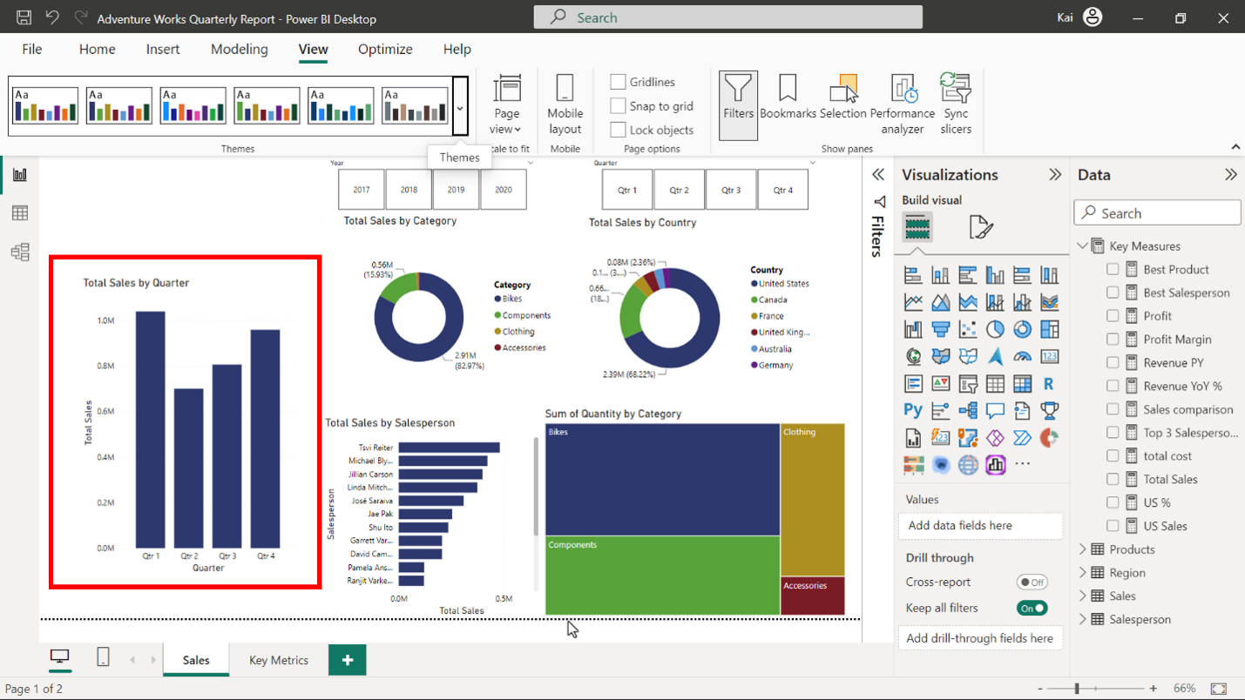

Once the visual elements are created, you need to format them to create a consistent and coherent look. In **Visualizations** > **Format visual**, there are two tabs for visual formatting; **Visual** and **General**. You need to adjust the font size of axis title and values to 12, chart title to 16, and legend to 12. You also need to make sure the text color is black throughout your report.

In the **slicers**, you can either set a background color or create a border to differentiate the **slicers** from the rest of the report.

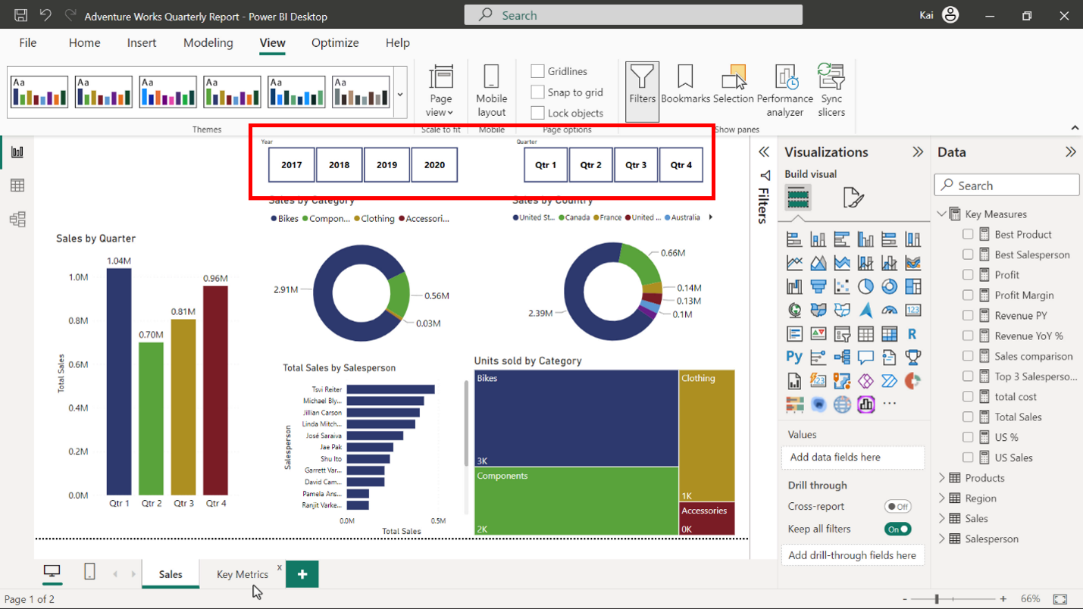

For card visuals, you can either create a colored background or use other design elements to make them stand out. Power BI has two card visuals; **Card** and **Card (New)**. You can use **Card (New)** as this provides more design options.

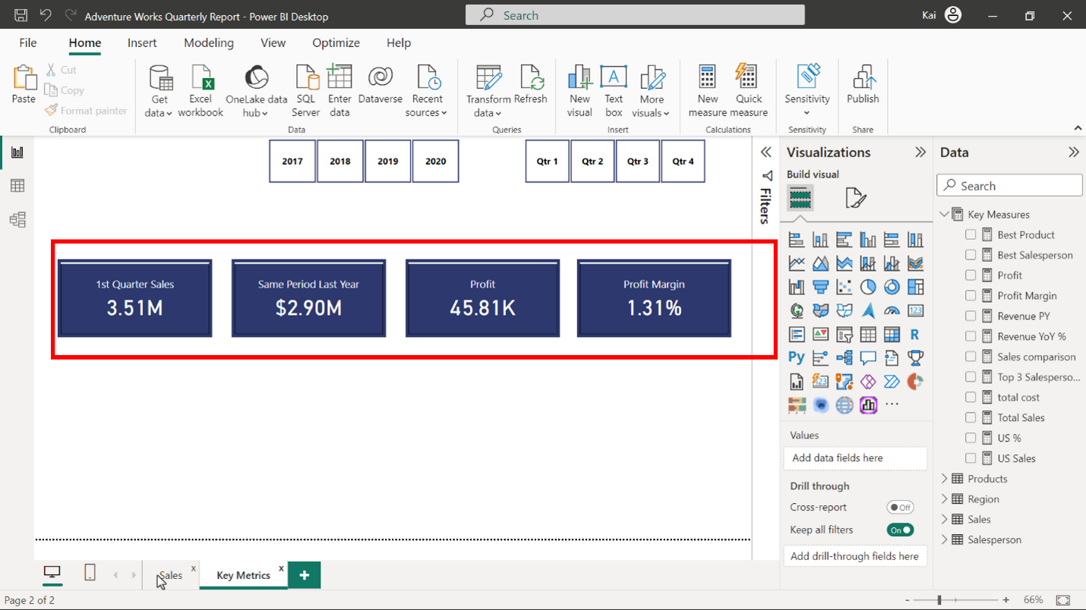

**Step 3: Craft a data story for the sales team.**

1. You need to add a descriptive title to your story and mention the period of time your visualization covers. For example, you can add “Adventure Works quarterly performance report” for the sales team. Add a text box from the **Insert** tab of Power BI desktop, where you can write and format the text.

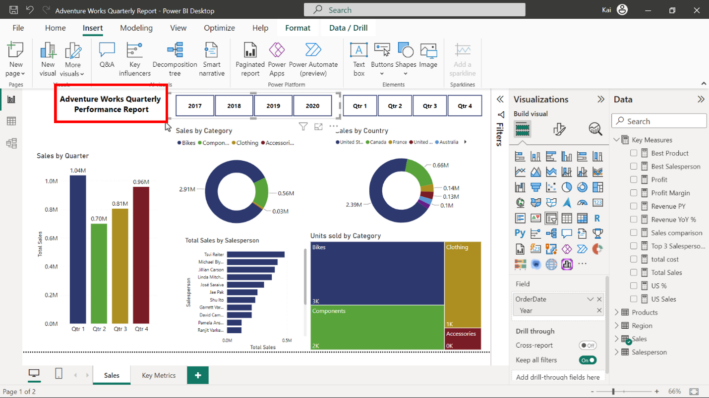

1. Arrange the visual elements created in step 2 that are relevant to your story in a logical sequence.  For the sales team report, you can use a column chart showing Sales by Quarter, two donut charts visualizing Sales by Country and Category, and a bar chart showing Sales by Salesperson. The treemap seems unrelated to the entire sales story so you can move this chart to the second page of your report which you may use for other visualizations. Additionally, you need to add two slicers which enable the users to interact with the report and compare the data between the quarters and years.

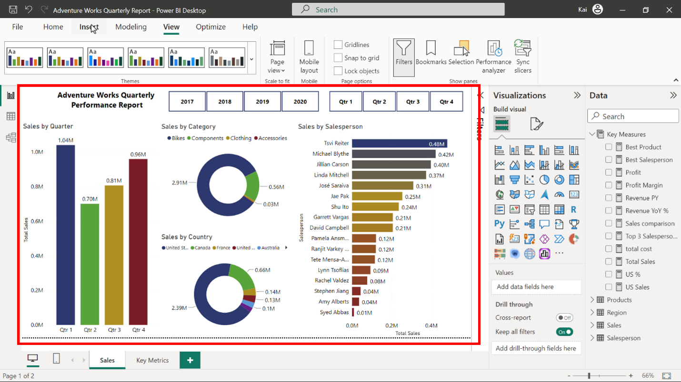

1. Add the Adventure Works logo to your report. From the **Insert** tab on the ribbon, select **Image** and navigate to the folder where you saved the Adventure Works logo file. Adjust the position and scaling of the logo to the top left of the report canvas.

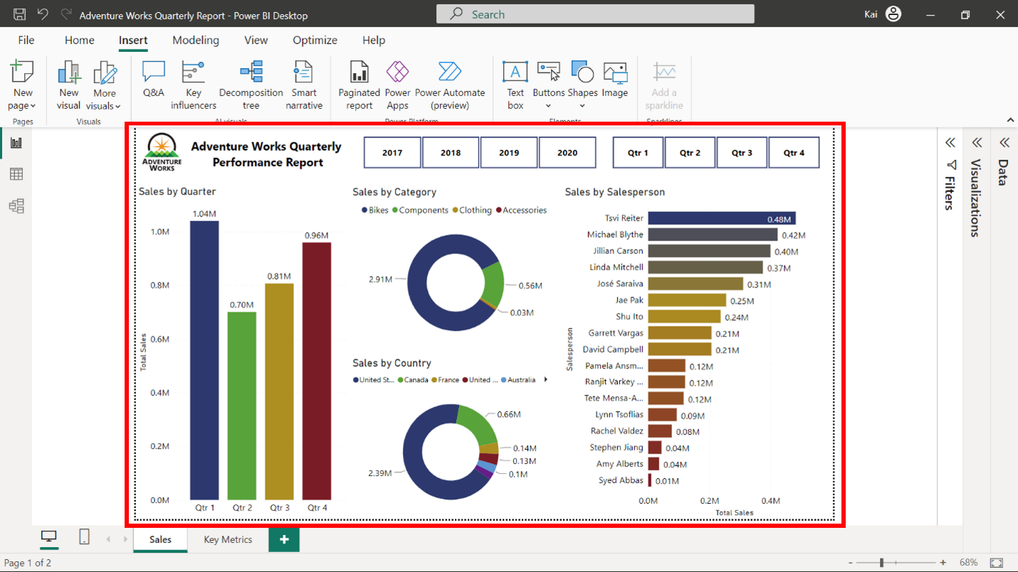

**Step 4: Craft a data story for the executive board.**

1. To create a dashboard for the executive board, you must publish your report to **My workspace** in Power BI service. You need to make sure you apply all changes made and your report is saved to your local computer before publishing. Select **Publish** from the **Home** tab on the ribbon and select **My workspace** to publish your report.

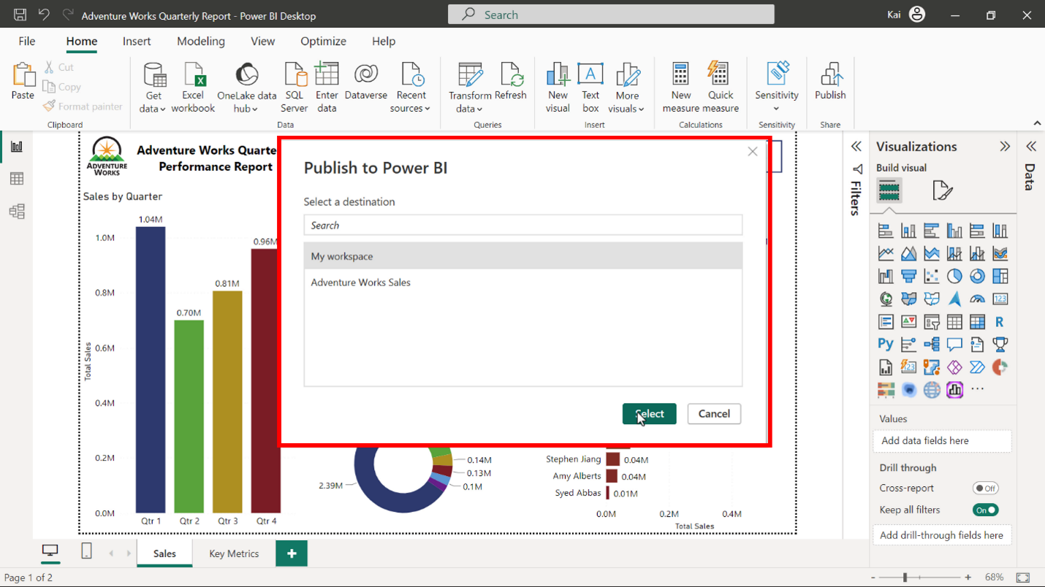

1. Log in to your Power BI service account and create a dashboard to tell a story to the executive board. From **My workspace,** open the report you published. Select **Pin visual icon** represented by a pin from any chart and select **New dashboard** from the **Pin to dashboard** box. Provide an appropriate name to the dashboard and select **Pin**.

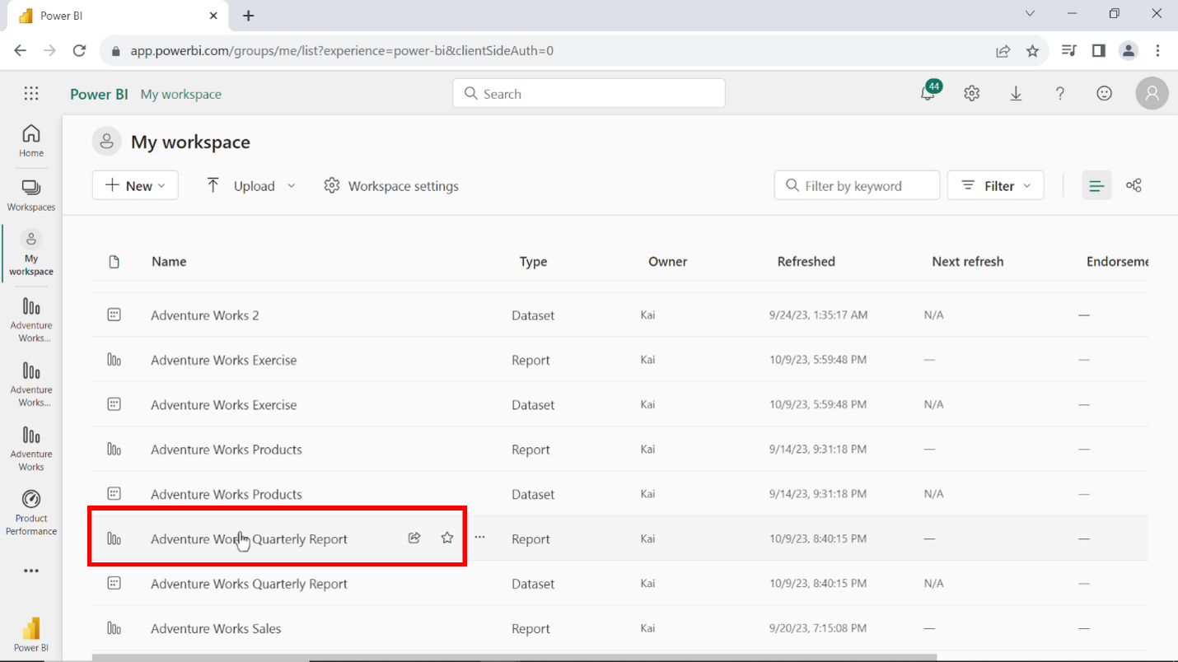

Before you pin any visual element to the dashboard, you need to apply filters to the report for the first two quarters of 2020. For column and donut charts, by selecting 2020 from the year slicer will display the data only relevant to the first two quarters of the year. Now you can pin these visuals to the dashboard.

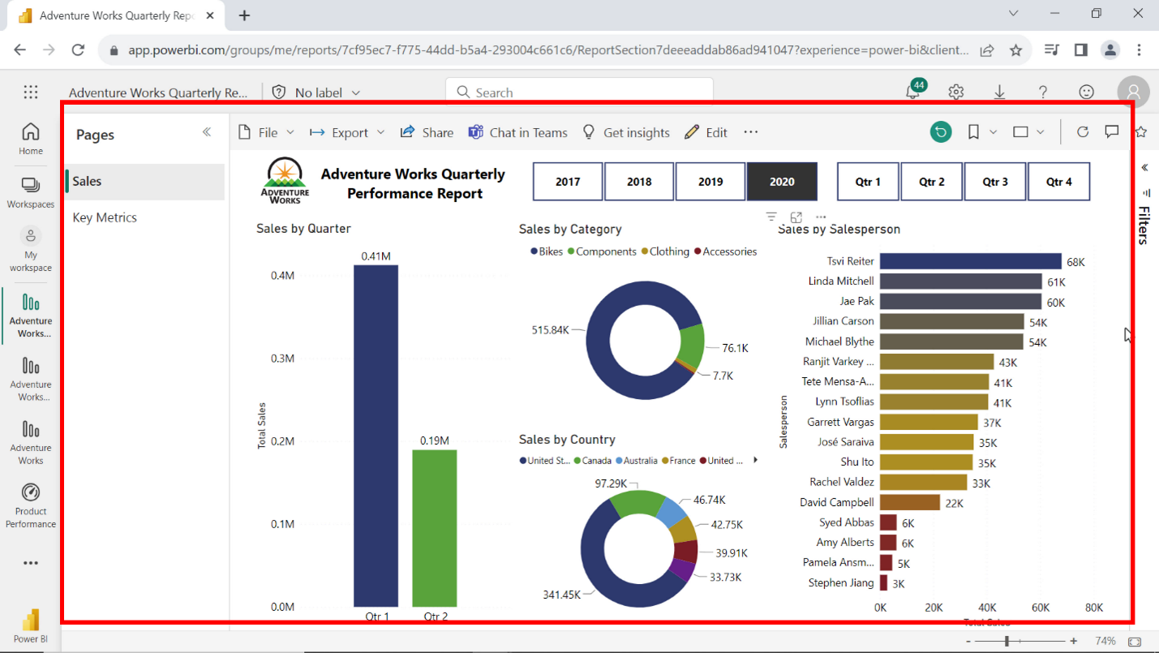

For card visuals, you need to apply both year and quarter filters to display only the values for the first quarter of the year, then you need to pin to the dashboard.

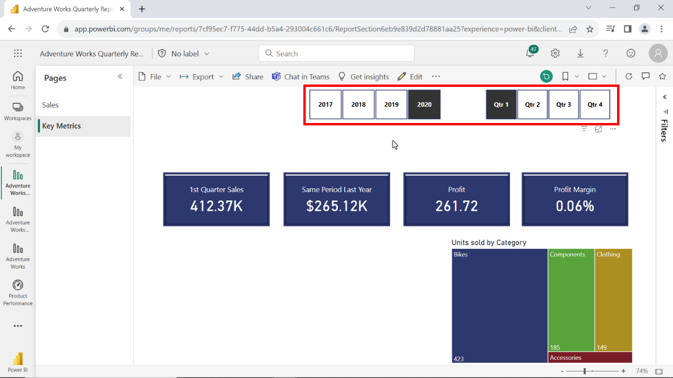

Make sure to rename the visuals according to the filters applied.

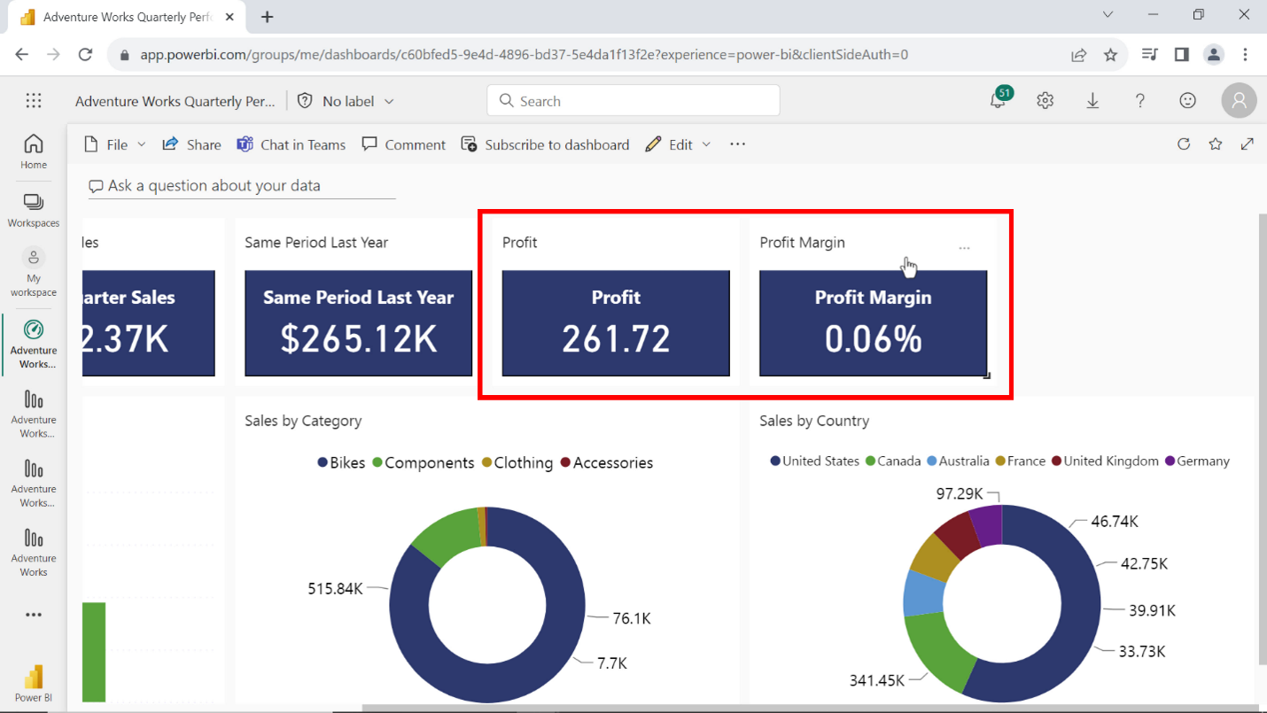

1. Add the Adventure Works logo to the dashboard. Publish the logo file that you have downloaded online without applying any security credentials and add it to the dashboard. You need to adjust the size and position of the logo to the dashboard.

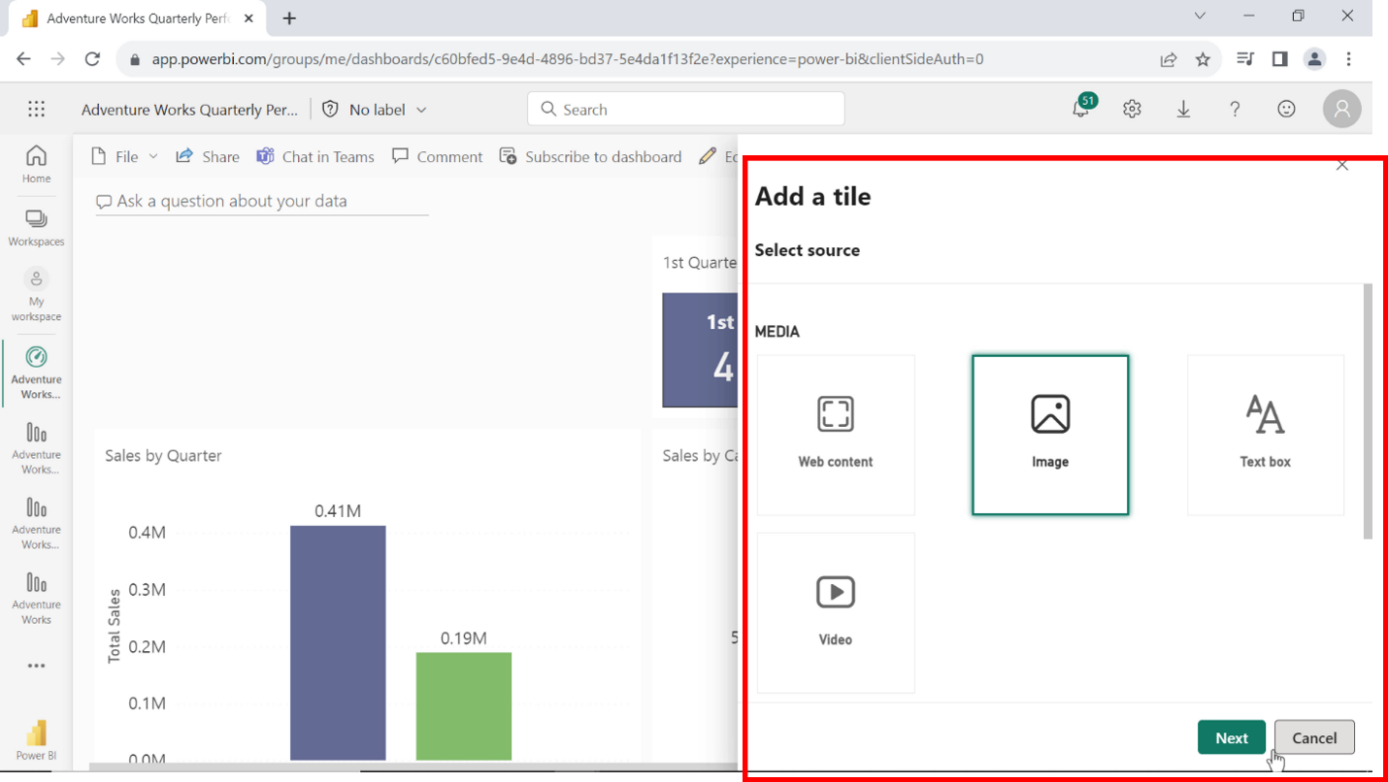

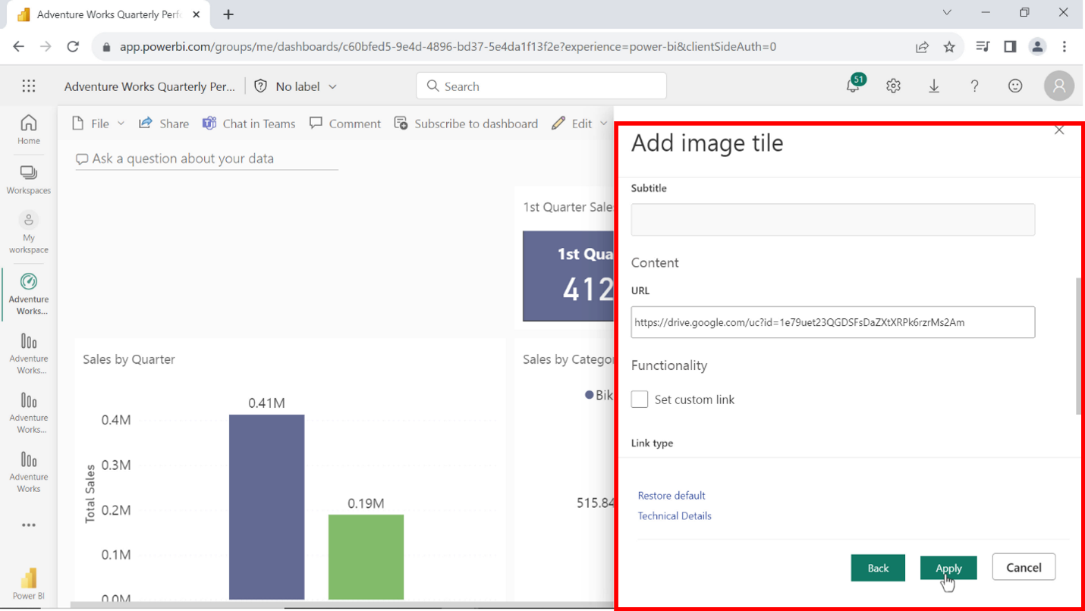

1. Provide a title and key takeaways from the story. You can add a text box to each to add a title and to describe the key insights.

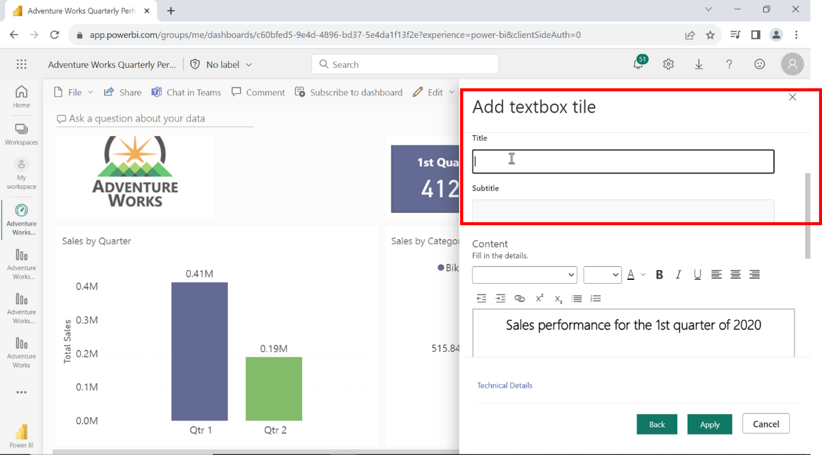

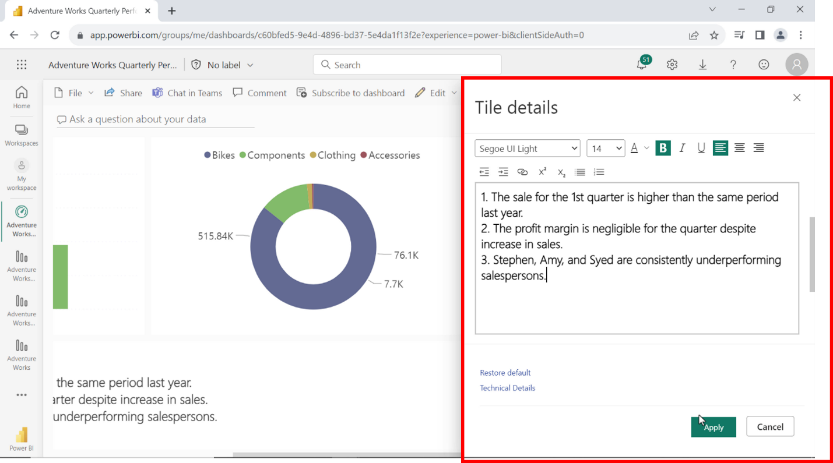

1. You need to optimize the dashboard for cellular devices. In Power BI service, open the dashboard you have created and from the **Edit** drop down select **Mobile layout**. Adjust the tiles scales and position to fit the mobile screen.

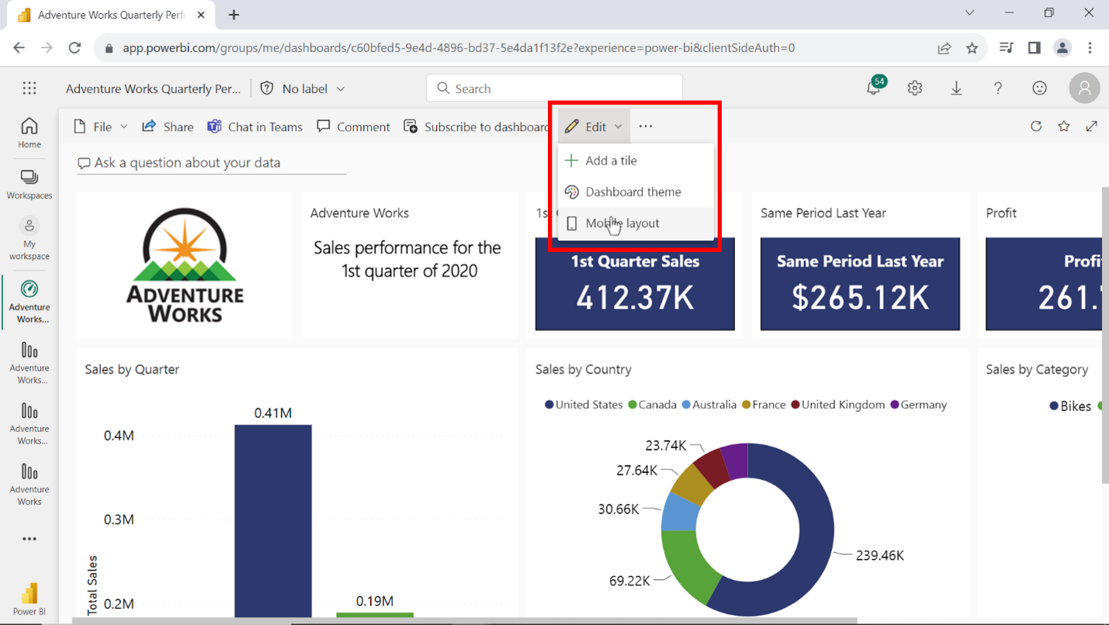

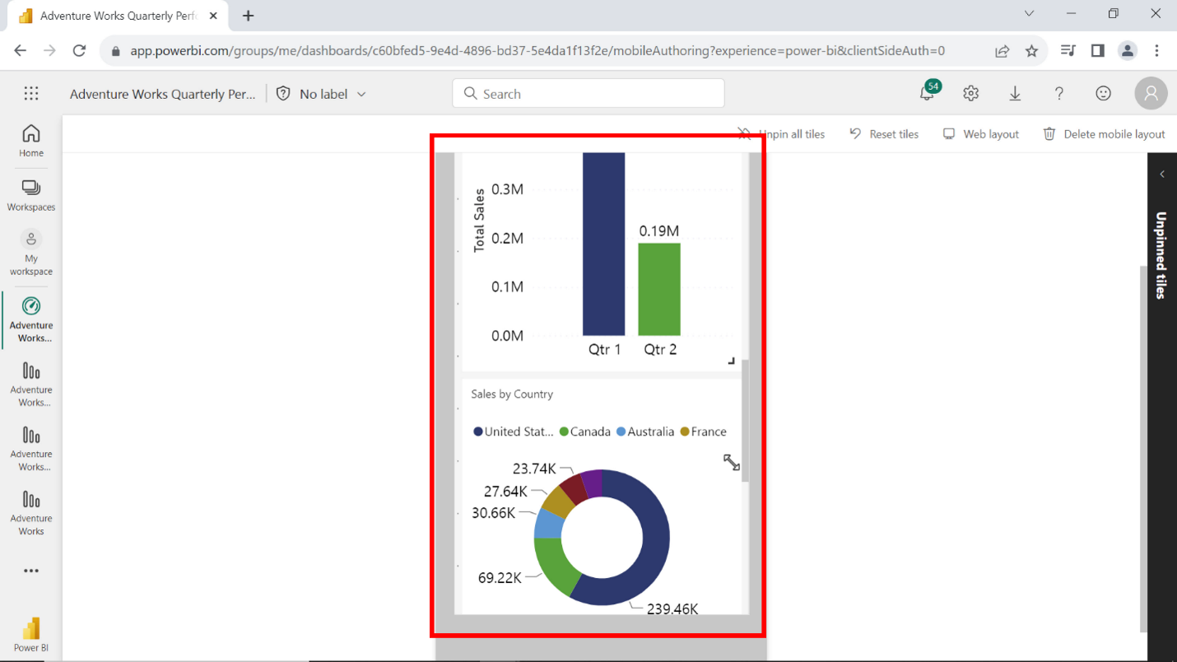

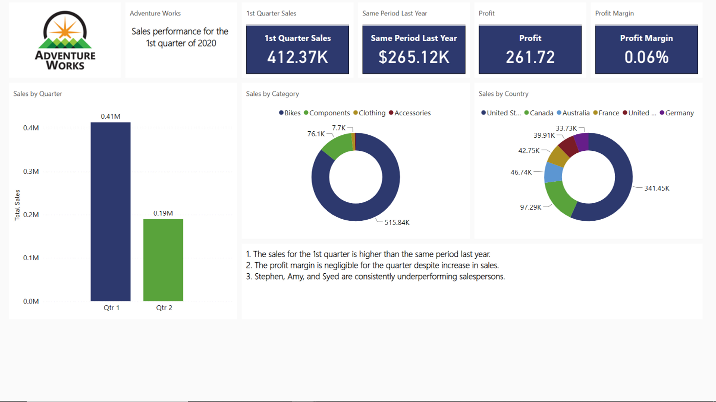

**Conclusion**

Your objective for this exercise was to complete the following tasks:

* Review the dataset and identify the measures and fields needed to support your story.
* Create a report in Power BI desktop by appropriate selection of chart which shows clarity to present your story.
* Publish your report on the Power BI service and create a dashboard for the executive board.
* Drive insights from your story that you can convey to stakeholders.

With these steps, you have successfully crafted a story as a Power BI report for the sales team. The report contains slicer and filter functionality which will enable users to interactively navigate the report to compare the sales value between quarters. Similarly, you also published the report to design and optimize the dashboard for the executive board. Use of slicers and filters sometimes, eliminating the need to write DAX logic to answer specific business questions.